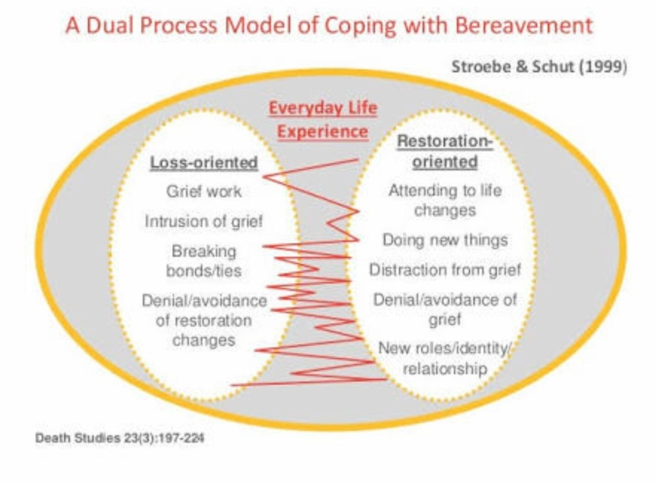
The Dual Process Model
An outline of Stroebe and Schut’s dual process theory
Last updated: 5 October 2017

In the mid-90s, Margaret Stroebe and Henk Schut came up with a model of grief called the dual process model. This bereavement theory suggests that grief operates in two main ways and people switch back and forth between them as they grieve.

You may have heard people talk about how grief has to be ‘worked through’ or ‘faced head on’. Stroebe and Schut do not believe that this is true. They suggest that sometimes ignoring your emotions, or distracting yourself from your grief, is a natural way of coping with grief.
This theory of grief describes two different ways of behaving: loss-oriented and restoration-oriented. As you grieve, you will switch, or ‘oscillate’, between these two different modes of being. This is why it is called the dual process model, because two different processes are happening.

Loss-oriented
Things that make you think about your loved one and their death are called loss-oriented stressors. In essence, these are thoughts, feelings, actions and events that make you focus on your grief and pain.

This may involve things like thinking about how much you miss your loved one, looking at old photos, or recalling a particular memory. Loss-oriented stressors can bring up lots of powerful emotions, such as sadness, loneliness and anger.

Restoration-oriented
Restoration-oriented stressors are things that let you get on with daily life and distract you from your grief for a while. Even for a few minutes, these thoughts and activities will allow you a small break from focusing on your pain.

A common restoration-oriented stressor is working or cleaning the house. Some people cope with grief by taking on on a tough work assignment or by tending to everyday chores in order to give themselves something other than their pain to focus on. Other examples include watching a funny TV show, going out with friends, or doing exercise.
You may think that repressing or ignoring emotions is unhealthy. In some cases this true, but Stroebe and Schut believe that for most people it is actually a normal way of coping with grief. It is our mind’s way of easing the pain a little and giving us at least a few moments where we can get important practical tasks done.
Stroebe and Schut argue that without restoration-oriented behaviour, you could end up completely unable to look after yourself or get on with daily life. In this way, it is a vital part of carrying on after the death of a loved one. It is called restoration-oriented because it is behaviour that is trying to restore order and normality.

Oscillation
Oscillation refers to the way that a grieving person can move back and forth between the two modes of being; loss-oriented and restoration-oriented. Stroebe and Schut say that the bereaved should embrace this oscillation, as you can move in and out of intense grief and tackle the reality of the loss bit by bit.

You may have been oscillating between the two modes without realising it. Perhaps in the morning you watched television and for a while you were distracted by an interesting news story – that’s restoration-oriented. Then you saw an advert that made you think of a particular memory of your loved one, which made you cry – that’s loss-oriented. After crying for a while, you thought, “Right, I really need to clean the kitchen.” And while focusing on cleaning, for even the briefest of moments, you feel less focused on your pain – you’ve moved back to restoration.

Some people find the dual process model a helpful way of thinking about their grief because it does not put emphasis on confronting your feelings. If you struggle to express your emotions, or find that distraction helps you cope, you might find the dual process model more accurately reflects your experience.

Stroebe and Schut also argued that the dual process model is useful for men, whereas previous theories of grief focused on a very stereotypically female way of grieving; namely, expressing emotions directly and working through them. Men, they noted, are often more likely to use restoration-oriented activities to help them cope, and this model of grief acknowledges that as a healthy, normal way of grieving.

